Regression – Chapter 12

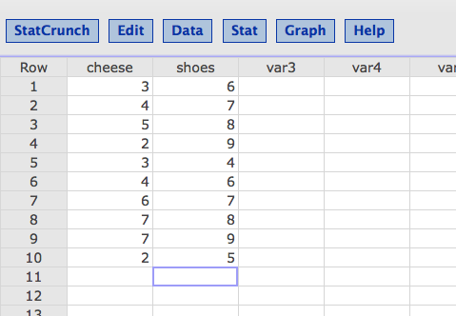

Click stat > regression > simple linear.

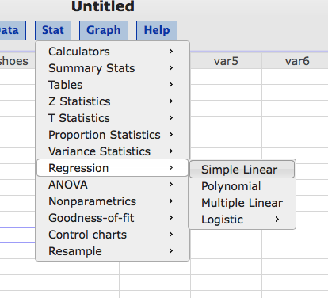

Put one of your variables in X – remember this needs to be the predictor.

Put one of your variables in Y – remember this needs to be the criterion variable.

Examples:

X predicts Y.

Using X to predict Y.

Determining Y with X scores.

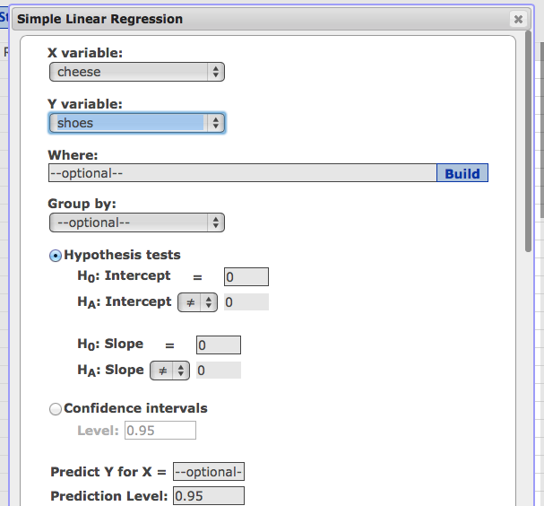

If you are given a value of X to figure out Y, you can enter it here in Predict Y for X (where it says optional).

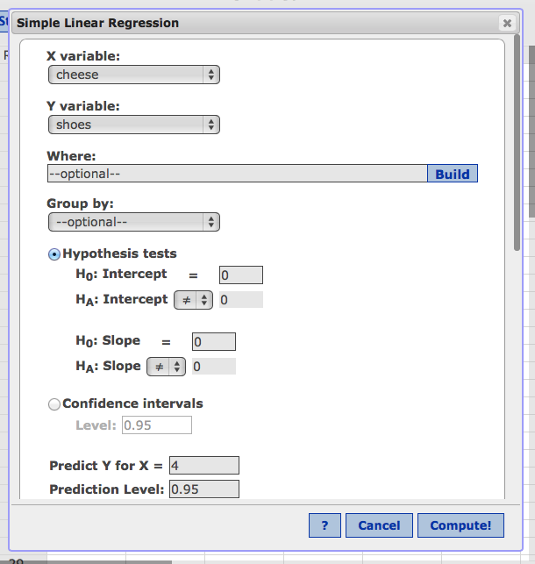

The rest you’ll want to leave alone. Hit compute.

On the first page, you’ll find most of the information you need for the steps.

**Simple linear regression results:**

Dependent Variable: shoes

Independent Variable: cheese

**shoes = 4.9844237 + 0.44548287 cheese LINEAR PREDICTION RULE**

Sample size: 10

**R (correlation coefficient) = 0.50580585 BETA (STEP 2)**

R-sq = 0.25583956 **EFFECT SIZE**

Estimate of error standard deviation: 1.5219065

**Parameter estimates:**

|  |  |  |  |  |  |  |
| --- | --- | --- | --- | --- | --- | --- |
| **Parameter** | **Estimate** | **Std. Err.** | **Alternative** | **DF** | **T-Stat** | **P-Value** |
| Intercept | 4.9844237 | 1.2513112 | ≠ 0 | 8 | 3.9833607 | 0.004 |
| Slope | 0.44548287 | 0.26861821 | ≠ 0 | **8** | **1.6584239** | 0.1358 |

**DF FOR STEP 2**

**T-STAT FOR STEP 4**

**Analysis of variance table for regression model:**

|  |  |  |  |  |  |
| --- | --- | --- | --- | --- | --- |
| **Source** | **DF** | **SS** | **MS** | **F-stat** | **P-value** |
| Model | 1 | 6.370405 | 6.370405 | 2.7503699 | 0.1358 |
| Error | 8 | 18.529595 | 2.3161994 |  |  |
| Total | 9 | 24.9 |  |  |  |

**Predicted values:**

|  |  |  |  |  |
| --- | --- | --- | --- | --- |
| **X value** | **Pred. Y** | **s.e.(Pred. y)** | **95% C.I. for mean** | **95% P.I. for new** |
| 4 | 6.7663551 | 0.48796921 | (5.6410961, 7.8916142) | (3.0808488, 10.451861) |

**PREDICTED Y FOR YOUR X VALUE.**

Hit the next > at the bottom to see your picture with regression line.

